January 2022

Emergency Broadband Benefit Transitions to The Affordable Connectivity Program
  - Preparing for Program Transition

The Federal Communications Commission (FCC) Emergency Broadband Benefits Program (EBB) is transitioning to the Affordable Connectivity Program (ACP). Get ready to participate in the program, educate your staff, and enroll/transition subscribers.

READINESS SNAPSHOT (Anticipated Practices)
To participate in the program and receive reimbursement for an EBB or ACP customer credit, a company must have an approved USAC Election, a qualified subscriber enrolled in NLAD, and an LCS claim submitted by the due date. Final requirements will be determined after the final FCC order anticipated in late January 2022. Readiness preparation might include:

Service Provider Participation – ACP USAC Election
Existing EBB Providers
- Existing EBB Providers will be transitioned to the ACP without additional documentation required during the interim period prior to final ACP rules.
New Providers (not currently providing EBB)
- New Providers with ETC status complete an EBB/ACP USAC Election
- New Providers without ETC status must acquire FCC approval prior to ACP USAC election
Note: Subscribers may apply a credit to any internet service offering.

Subscriber Application and Eligibility Verification Readiness
Existing EBB Subscribers
- Subscribers with valid eligibility criteria will be transitioned to the ACP by service provider after 60 day window
- Subscribers with invalid eligibility criteria will be required to provide additional information or be de-enrolled during the 60-day transition period.

New EBB/ACP Subscribers
- National Verifier and/or Alternative Verification Process

Service Provider NLAD Enrollment/De-enrollment Preparation
- EBB to ACP Program Notifications
- Affirmative Opt-In or Application (Required – subscribers must request enrollment)
    - Affirmative Opt-in is required for new subscribers to the ACP. Existing EBB subscribers are automatically transitioned into the program.
- Initial Disclosures
- Application of Credit on Consumer Invoice

Service Provider USAC LCS Claim Submission Planning
- Are all still active subscribers?
- Did all subscribers utilize broadband?
- Submission by the 15th

PREPARING FOR PROGRAM SUCCESS (Anticipated Practices)

Subscriber Eligibility
Subscribers who participate in SNAP, Medicaid, Veterans Pension, National School Lunch Program, WIC, or an identified tribal program will qualify for the ACP. Subscribers who are low income can qualify based on low income at 200% of the Federal Poverty Level.
Existing EBB subscribers will maintain their benefits through March 1, 2022.
New qualifying ACP Subscribers will receive $30 or $50 (tribal or particularized economic hardship providers) for broadband and $100 for a computer, laptop, or tablet per household.
To apply subscribers must apply and be approved via an FCC approved verification method (USAC’s National Verifier, the National School Lunch Program, or your company’s specific eligibility verifying program). For additional information on the ACP program subscribers can go to the ACP website at: http://www.ACPbenefit.org

NLAD Enrollment/De-enrollment
To enroll subscribers, a service provider must have access to USAC’s One-Portal System. All employees working with subscriber PII will be required to provide a RAD ID. The ID will be utilized in the NLAD user account creation.
» The RAD ID website is: https://lifelinerad.org/rad/#/Landing
The service provider process for ACP enrollment is similar to the EBB business practices. Once in the system select Lifeline and National Lifeline Accountability Database (NLAD). The associated menus will allow subscribers to be enrolled, transferred, and updated.
The subscriber must be enrolled in NLAD by the 1st of the month for the service provider to receive reimbursement for the prior month.
» For additional consumer information go to: https://www.usac.org/about/emergency-broadband-benefit-program/

USAC LCS Claim Submission
Each month a claim for the prior month must be submitted by the 15th. Prior to submission, a service provider must validate the subscriber’s eligibility and verify their usage. The graphic below depicts the program processes.
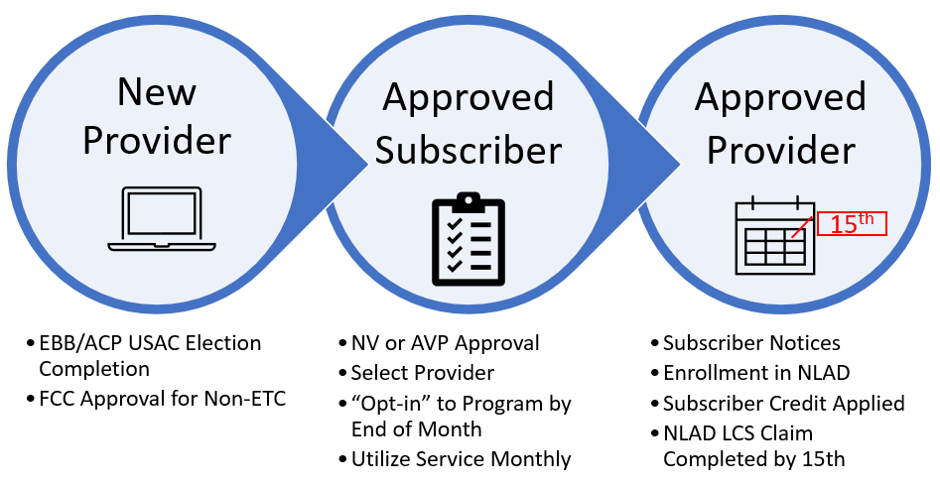

IMMEDIATE ACTIONS RECOMMENDED
What can providers do now to prepare for the program opening by the FCC? Vantage Point recommends validating your business practices and processes. Below are a couple of examples to review:
Is your company eligible to participate in the program?
- Existing EBB providers automatically transitioned to ACP during interim period
- New EBB/ACP providers with ETC status complete ACP USAC Enrollment
- Non-ETC’s acquire FCC approval prior to submission of ACP USAC enrollment.
- ZIP codes to be serviced will be required
How will your company market and educate subscribers?
- Website development
- Public awareness campaign with local agencies
How will your company enroll the following types of subscribers?
- Existing lifeline or EBB subscriber (have 60-day transition period prior to movement to ACP)
- Existing broadband subscriber (EBB/ACP eligibility determination required)
- New broadband subscriber (EBB/ACP eligibility determination required)
How will your company manage the financial transactions?
- Subscriber credit
  - Review criteria – it is TBD if modems, routers, and hotspot rentals will be eligible for the ACP
  - EBB/ACP benefit will be applicable to all internet service offerings starting December 31, 2021
- Receipt of payment from SAM.gov
- Retention of documentation of subscriber financial transaction for device match.
- How will your company produce reports validating customer usage?

HERE TO HELP
For additional information on the EBB to ACP transition or if you would like Vantage Point Solutions guidance, please contact any of these members of the Vantage Point Solutions Consulting Team:

 |  | 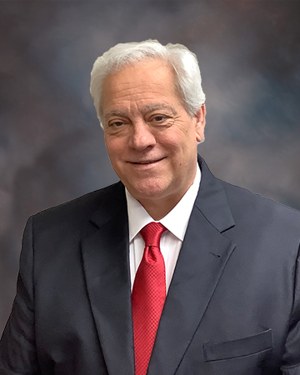
Tammie Herrlein  (605) 990-1861  Tammie.Herrlein@vantagepnt.com | Dereck DeVries  (605) 995-1762  Dereck.Devries@vantagepnt.com | Steve Gatto, JD  (830) 895-7226  Steve.Gatto@vantagepnt.com
Or contact your Customer Relations representative.

